**Personal Progress Report No.2**

**X- Axis ( Rosani and I)**

From the previous term, the Ball Screws that had been decided from **THK** website, will be changed into NSK due to the unavailability from the THK. As the results, the process of re-selection of the ball screws on NSK brand leads to the rolled ball screws of R serries( RNTL 1405A2.5S)

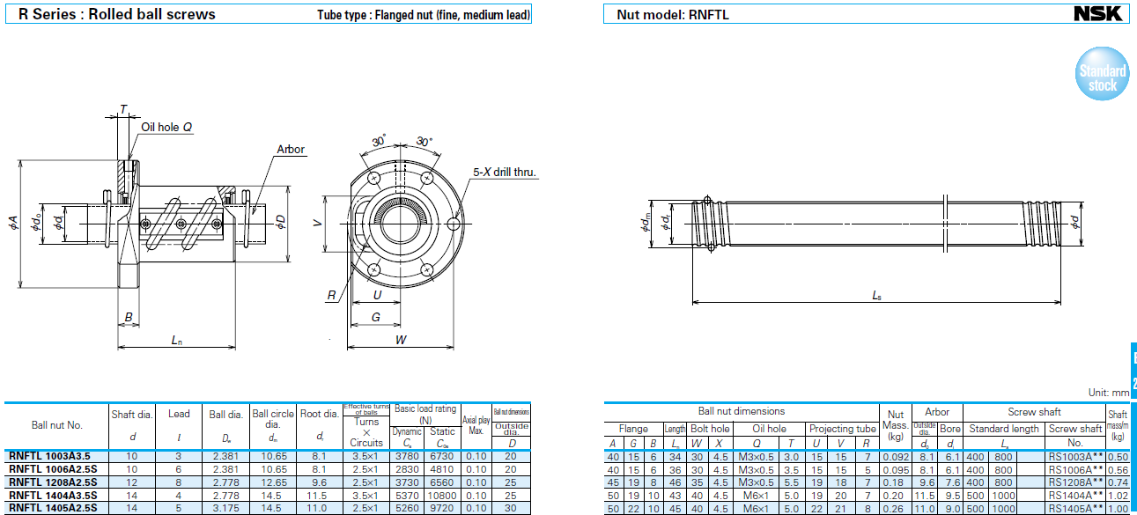

The previous ball screws has a shaft diameter of **16mm**. However, the one from the NSK does not have the same diameter in the data sheet. **NSK** has only **14mm** diameter so that closer to the original selection according to the calculation.

For the shaft, the length has been decided at 530mm. However, the default order is 600mm or 1200mm so that we will modify the shaft when it arrives.

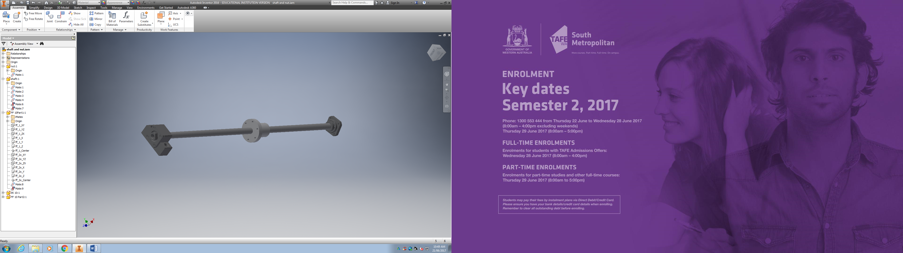

In addition, the shaft has the rectangular fixed support and round support at the other end.

**The cross-slide limitation** will be -40mm and 60mm in the X-Axis.

Disassembly the apron to modify later on.

Base on the saddle, create the support to hold the motor that will control the ball screws along the X-Axis.